Scordelis-Lo Roof Validation in Kratos with IGA element

Objective:
Validate the Scordelis-Lo Roof with Kratos IGA Shell3pElement for linear analysis for both strong and weak BC and perform a convergence study.
Validation is performed against Josef M. Kiendl's Dissertation – Benchmark 6.2.1

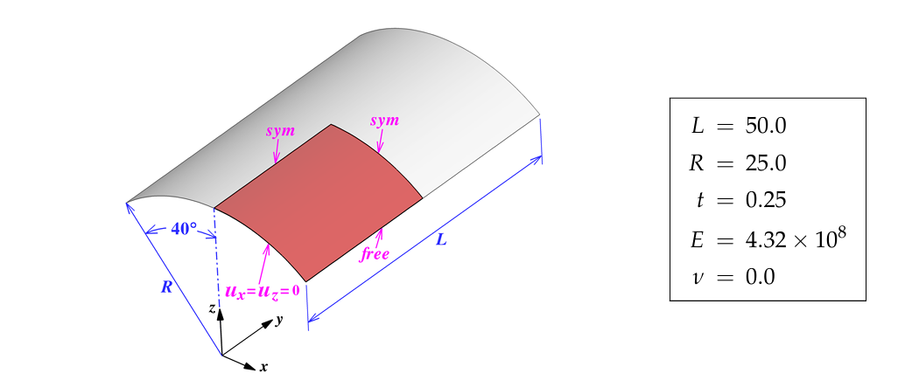
- Model Description:
Fig.1: Scordelis-Lo Roof - Taken from Josef M. Kiendl's Dissertation

- Results:
2.1 Strong BC
Maximum displacement, ie, Displacement Z at the middle of the roof, is taken for the convergence study. For strong BC, the convergence was achieved. Tables 1,2, and 3 show convergence behaviour for different polynomial degrees. Figure 1 shows the convergence plot

Control Point Refinement | Number of Control Points | Displacement Z
5 | 8 | -0.16537
8 | 11 | -0.25836
10 | 13 | -0.28012
20 | 23 | -0.29888
40 | 43 | -0.30044
Table 1: Convergence study with polynomial degree 2

Control Point Refinement | Number of Control Points | Displacement Z
5 | 9 | -0.297
8 | 12 | -0.30031
Table 2: Convergence study with polynomial degree 3

Control Point Refinement | Number of Control Points | Displacement Z
0 | 5 | -0.2593
2 | 7 | -0.294
5 | 10 | -0.3007
Table 3: Convergence study with polynomial degree 4

Figure 1: Combined Convergence Plot

2.2 Weak BC
In weak BC, there might be an inbuilt error with Kratos; the converged z-displacement value was -0.153. This shall be because, when a weak BC with a penalty is used, all directions of DOF get constrained irrespective of the inputs given in the Projectparameters.json file. This shall be checked by altering the support conditions for the displacement constraint in the project parameters file, and there won't be any change in the converged z-displacement. Also, when we constrain model 2.1 in all three directions, the z-displacement obtained is -0.153, which is the same as the weak BC. Hence there might be an inbuilt error with Kratos.

